Чем занять ребенка на даче?

[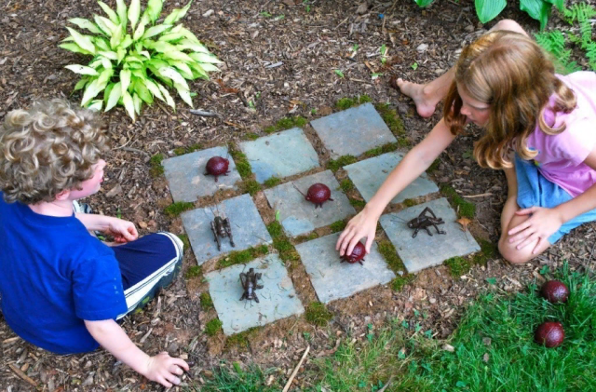](https://ok.ru/dk?cmd=PopLayerPhoto&st.layer.cmd=PopLayerPhotoOuter&st.layer.type=GROUP&st.layer.revNav=off&st.layer.limitedUi=false&st.layer.closeLayers=off&st.layer.sphotoIds=899930546220;899930548012;899930551340;899930553900;899930557996;899930561580;899930564396;899930568236;899930573100;899930575148&st.layer.showNav=on&st.layer.photoAlbumId=56909490225196&st.layer.epm=off&st.layer.photoId=899930546220&st.layer.wasRedirect,=off&st.layer.opl=off&st.layer.navStartPhotoId=899930546220&st.layer.navStartAlbumId,=56909490225196&st.layer.sbd=off&st.cmd=altGroupMain&st.groupId=56898903474220&st.referenceName=group56898903474220&st._aid=GroupTopicLayer_openPhotoLayer)

[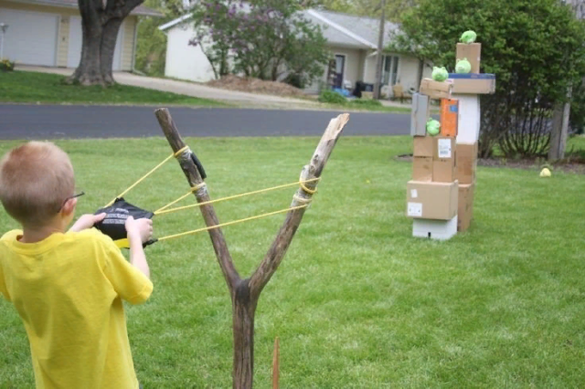](https://ok.ru/dk?cmd=PopLayerPhoto&st.layer.cmd=PopLayerPhotoOuter&st.layer.type=GROUP&st.layer.revNav=off&st.layer.limitedUi=false&st.layer.closeLayers=off&st.layer.sphotoIds=899930546220;899930548012;899930551340;899930553900;899930557996;899930561580;899930564396;899930568236;899930573100;899930575148&st.layer.showNav=on&st.layer.photoAlbumId=56909490225196&st.layer.epm=off&st.layer.photoId=899930553900&st.layer.wasRedirect,=off&st.layer.opl=off&st.layer.navStartPhotoId=899930553900&st.layer.navStartAlbumId,=56909490225196&st.layer.sbd=off&st.cmd=altGroupMain&st.groupId=56898903474220&st.referenceName=group56898903474220&st._aid=GroupTopicLayer_openPhotoLayer)

[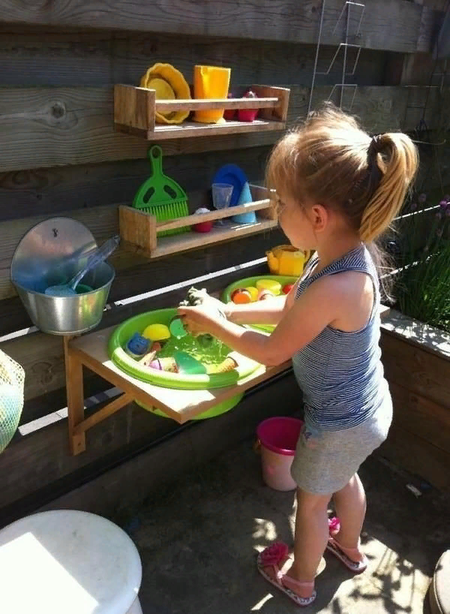](https://ok.ru/dk?cmd=PopLayerPhoto&st.layer.cmd=PopLayerPhotoOuter&st.layer.type=GROUP&st.layer.revNav=off&st.layer.limitedUi=false&st.layer.closeLayers=off&st.layer.sphotoIds=899930546220;899930548012;899930551340;899930553900;899930557996;899930561580;899930564396;899930568236;899930573100;899930575148&st.layer.showNav=on&st.layer.photoAlbumId=56909490225196&st.layer.epm=off&st.layer.photoId=899930548012&st.layer.wasRedirect,=off&st.layer.opl=off&st.layer.navStartPhotoId=899930548012&st.layer.navStartAlbumId,=56909490225196&st.layer.sbd=off&st.cmd=altGroupMain&st.groupId=56898903474220&st.referenceName=group56898903474220&st._aid=GroupTopicLayer_openPhotoLayer)

[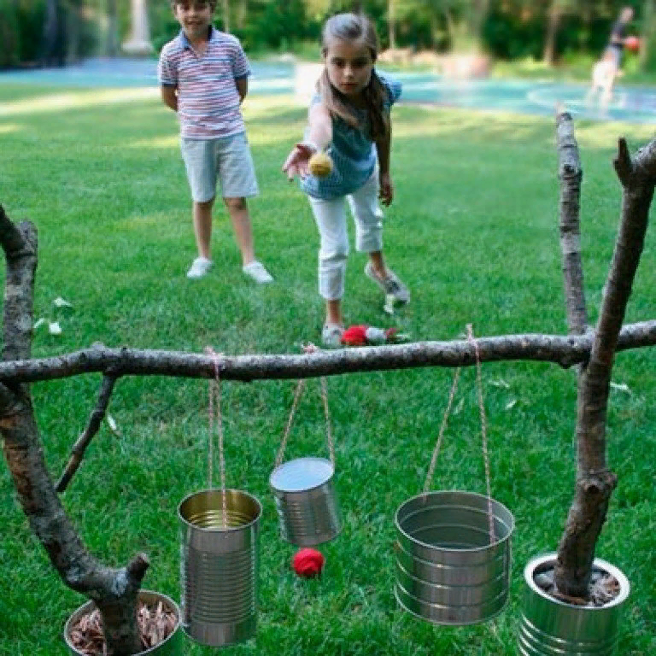](https://ok.ru/dk?cmd=PopLayerPhoto&st.layer.cmd=PopLayerPhotoOuter&st.layer.type=GROUP&st.layer.revNav=off&st.layer.limitedUi=false&st.layer.closeLayers=off&st.layer.sphotoIds=899930546220;899930548012;899930551340;899930553900;899930557996;899930561580;899930564396;899930568236;899930573100;899930575148&st.layer.showNav=on&st.layer.photoAlbumId=56909490225196&st.layer.epm=off&st.layer.photoId=899930551340&st.layer.wasRedirect,=off&st.layer.opl=off&st.layer.navStartPhotoId=899930551340&st.layer.navStartAlbumId,=56909490225196&st.layer.sbd=off&st.cmd=altGroupMain&st.groupId=56898903474220&st.referenceName=group56898903474220&st._aid=GroupTopicLayer_openPhotoLayer)

[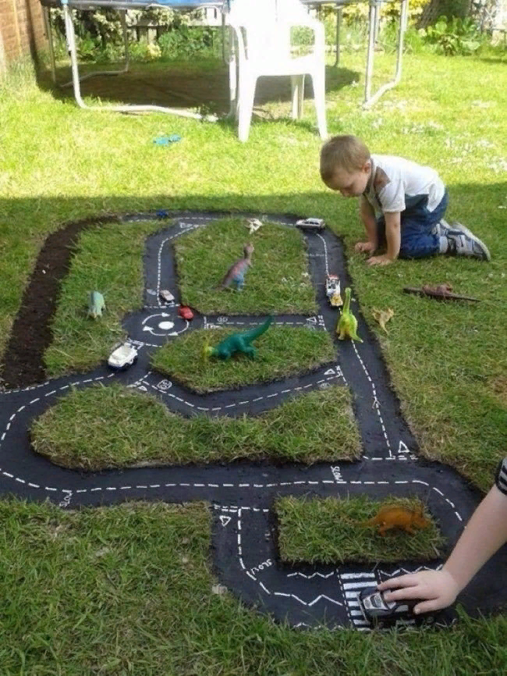](https://ok.ru/dk?cmd=PopLayerPhoto&st.layer.cmd=PopLayerPhotoOuter&st.layer.type=GROUP&st.layer.revNav=off&st.layer.limitedUi=false&st.layer.closeLayers=off&st.layer.sphotoIds=899930546220;899930548012;899930551340;899930553900;899930557996;899930561580;899930564396;899930568236;899930573100;899930575148&st.layer.showNav=on&st.layer.photoAlbumId=56909490225196&st.layer.epm=off&st.layer.photoId=899930557996&st.layer.wasRedirect,=off&st.layer.opl=off&st.layer.navStartPhotoId=899930557996&st.layer.navStartAlbumId,=56909490225196&st.layer.sbd=off&st.cmd=altGroupMain&st.groupId=56898903474220&st.referenceName=group56898903474220&st._aid=GroupTopicLayer_openPhotoLayer)

[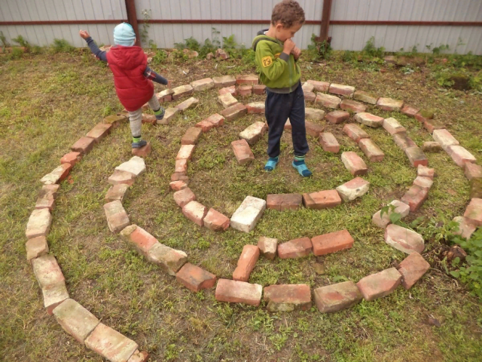](https://ok.ru/dk?cmd=PopLayerPhoto&st.layer.cmd=PopLayerPhotoOuter&st.layer.type=GROUP&st.layer.revNav=off&st.layer.limitedUi=false&st.layer.closeLayers=off&st.layer.sphotoIds=899930546220;899930548012;899930551340;899930553900;899930557996;899930561580;899930564396;899930568236;899930573100;899930575148&st.layer.showNav=on&st.layer.photoAlbumId=56909490225196&st.layer.epm=off&st.layer.photoId=899930564396&st.layer.wasRedirect,=off&st.layer.opl=off&st.layer.navStartPhotoId=899930564396&st.layer.navStartAlbumId,=56909490225196&st.layer.sbd=off&st.cmd=altGroupMain&st.groupId=56898903474220&st.referenceName=group56898903474220&st._aid=GroupTopicLayer_openPhotoLayer)

[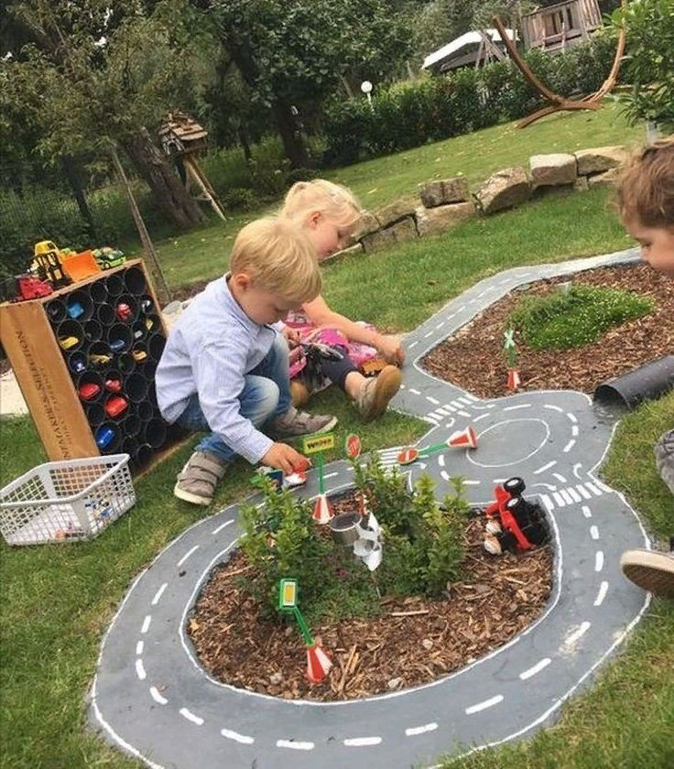](https://ok.ru/dk?cmd=PopLayerPhoto&st.layer.cmd=PopLayerPhotoOuter&st.layer.type=GROUP&st.layer.revNav=off&st.layer.limitedUi=false&st.layer.closeLayers=off&st.layer.sphotoIds=899930546220;899930548012;899930551340;899930553900;899930557996;899930561580;899930564396;899930568236;899930573100;899930575148&st.layer.showNav=on&st.layer.photoAlbumId=56909490225196&st.layer.epm=off&st.layer.photoId=899930561580&st.layer.wasRedirect,=off&st.layer.opl=off&st.layer.navStartPhotoId=899930561580&st.layer.navStartAlbumId,=56909490225196&st.layer.sbd=off&st.cmd=altGroupMain&st.groupId=56898903474220&st.referenceName=group56898903474220&st._aid=GroupTopicLayer_openPhotoLayer)

[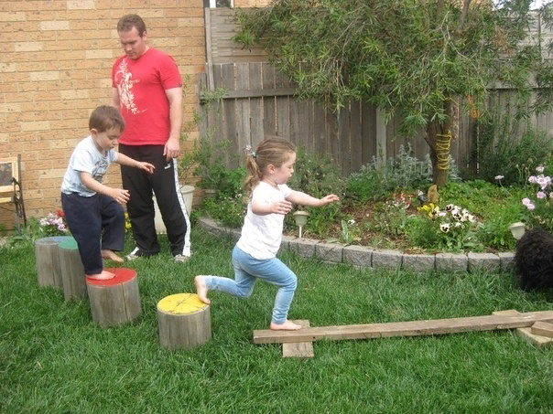](https://ok.ru/dk?cmd=PopLayerPhoto&st.layer.cmd=PopLayerPhotoOuter&st.layer.type=GROUP&st.layer.revNav=off&st.layer.limitedUi=false&st.layer.closeLayers=off&st.layer.sphotoIds=899930546220;899930548012;899930551340;899930553900;899930557996;899930561580;899930564396;899930568236;899930573100;899930575148&st.layer.showNav=on&st.layer.photoAlbumId=56909490225196&st.layer.epm=off&st.layer.photoId=899930568236&st.layer.wasRedirect,=off&st.layer.opl=off&st.layer.navStartPhotoId=899930568236&st.layer.navStartAlbumId,=56909490225196&st.layer.sbd=off&st.cmd=altGroupMain&st.groupId=56898903474220&st.referenceName=group56898903474220&st._aid=GroupTopicLayer_openPhotoLayer)

[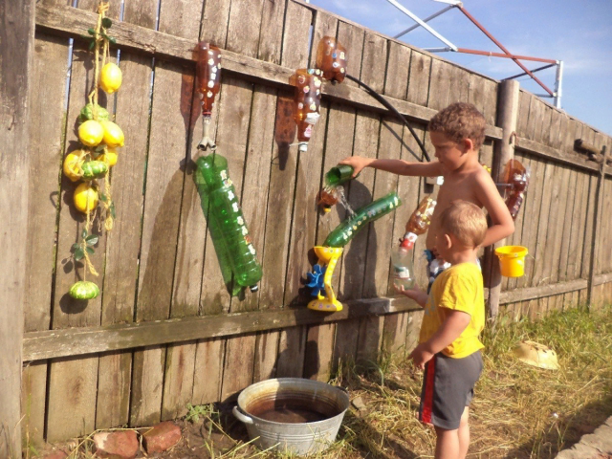](https://ok.ru/dk?cmd=PopLayerPhoto&st.layer.cmd=PopLayerPhotoOuter&st.layer.type=GROUP&st.layer.revNav=off&st.layer.limitedUi=false&st.layer.closeLayers=off&st.layer.sphotoIds=899930546220;899930548012;899930551340;899930553900;899930557996;899930561580;899930564396;899930568236;899930573100;899930575148&st.layer.showNav=on&st.layer.photoAlbumId=56909490225196&st.layer.epm=off&st.layer.photoId=899930573100&st.layer.wasRedirect,=off&st.layer.opl=off&st.layer.navStartPhotoId=899930573100&st.layer.navStartAlbumId,=56909490225196&st.layer.sbd=off&st.cmd=altGroupMain&st.groupId=56898903474220&st.referenceName=group56898903474220&st._aid=GroupTopicLayer_openPhotoLayer)

